**1. Site Search**

Site search bars help users quickly find what they’re after on a particular website. HubSpot found from previous analysis that visitors who interacted with its site search bar were more likely to convert on a blog post. So, we ran an A/B test in an attempt to increase engagement with the search bar.

In this test, search bar functionality was the independent variable and views on the content offer thank you page was the dependent variable. We used one control condition and three challenger conditions in the experiment.

In the control condition (variant A), the search bar remained unchanged.



In variant B, the search bar was made larger and more visually prominent, and the placeholder text was set to “search by topic.”

variant b of the hubspot search bar AB test

Variant C appeared identical to variant B, but only searched the HubSpot Blog rather than the entire website.

In variant D, the search bar was made larger but the placeholder text was set to “search the blog.” This variant also searched only the HubSpot Blog

variant c of the hubspot search bar AB test

We found variant D to be the most effective: It increased conversions by 3.4% over the control and increased the percentage of users who used the search bar by 6.5%.

**2. Mobile CTAs**

HubSpot uses several CTAs for content offers in our blog posts, including ones in the body of posts as well as at the bottom of the page. [**We test these CTAs extensively**](https://blog.hubspot.com/marketing/ab-testing-ctas) for optimize their performance.

For our mobile users, we ran an A/B test to see which type of bottom-of-page CTA converted best. For our independent variable, we altered the design of the CTA bar. Specifically, we used one control and three challengers in our test. For our dependent variables, we used pageviews on the CTA thank you page and CTA clicks.

The control condition included our normal placement of CTAs at the bottom of posts. In variant B, the CTA had no close or minimize option.



In variant C, mobile readers could close the CTA by tapping an X icon. Once it was closed out, it wouldn’t reappear.

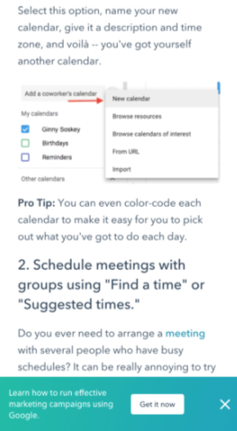

In variant D, we included an option to minimize the CTA with an up/down caret.

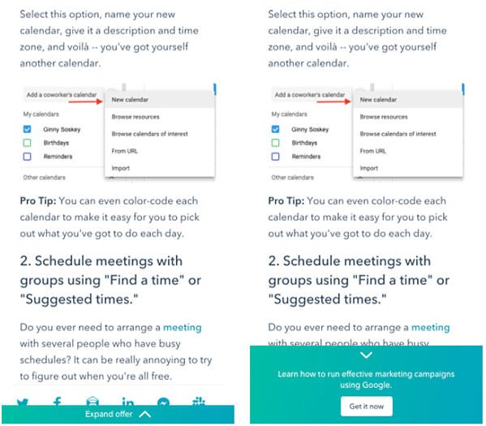

Our tests found all variants to be successful. Variant D was the most successful, with a 14.6% increase in conversions over the control. This was followed by variant C with an 11.4% increase and variant B with a 7.9% increase.

**3. Author CTAs**

In another CTA experiment, HubSpot tested whether adding the word “free” and other descriptive language to author CTAs at the top of blog posts would increase content leads. Past research suggested that using “free” in CTA text would drive more conversions and that text specifying the type of content offered would be helpful for SEO and accessibility.

In the test, the independent variable was CTA text and the main dependent variable was conversion rate on the content offer form.

In the control condition, author CTA text was unchanged (see the orange button in the image below).



In variant B, the word “free” was added to the CTA text.



In variant C, descriptive wording was added to the CTA text in addition to “free.”



Interestingly, variant B saw a loss in form submissions, down by 14% compared to the control. This was unexpected, since including "free" in content offer text is widely considered a best practice.

Meanwhile, form submissions in variant C outperformed the control by 4%. It was concluded that adding descriptive text to the author CTA helped users understand the offer and thus made them more likely to download.

**4. Blog Table of Contents**

To help users better navigate the blog, HubSpot tested a new Table of Contents (TOC) module. The goal was to improve user experience by presenting readers with their desired content more quickly. We also tested whether adding a CTA to this TOC module would increase conversions.

The independent variable of this A/B test was the inclusion and type of TOC module in blog posts, and the dependent variables were conversion rate on content offer form submissions and clicks on the CTA inside the TOC module.

The control condition did not include the new TOC module — control posts either had no table of contents, or a simple bulleted list of anchor links within the body of the post near the top of the article (pictured below).

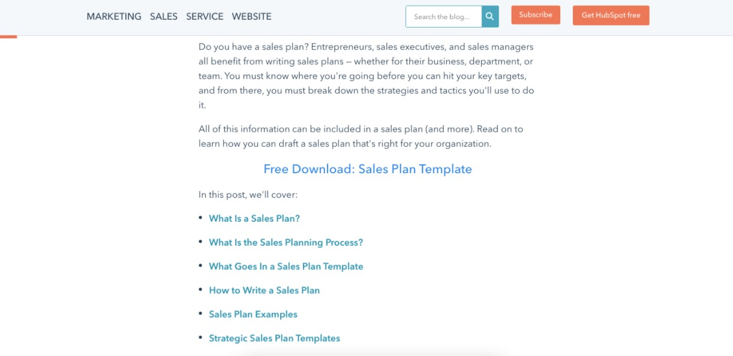

In variant B, the new TOC module was added to blog posts. This module was sticky, meaning it remained onscreen as users scrolled down the page. Variant B also included a content offer CTA at the bottom of the module.

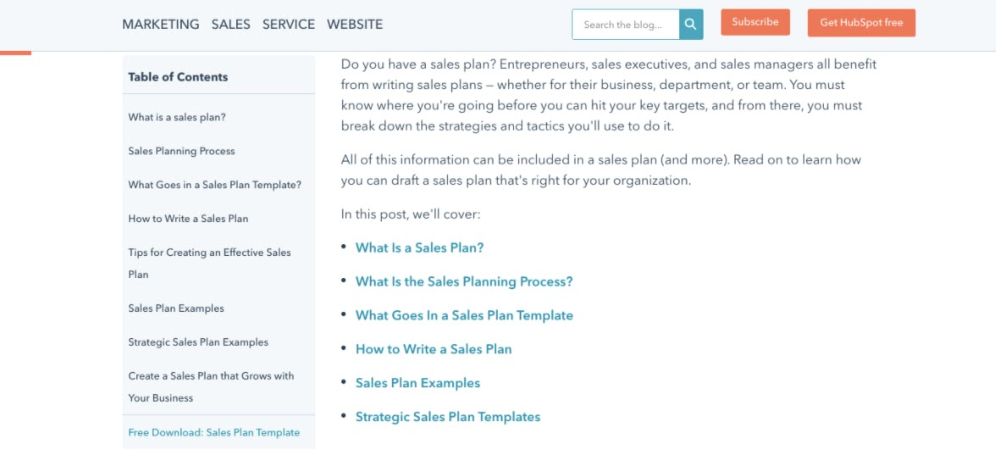

Variant C included an identical module to variant B but with the CTA removed.

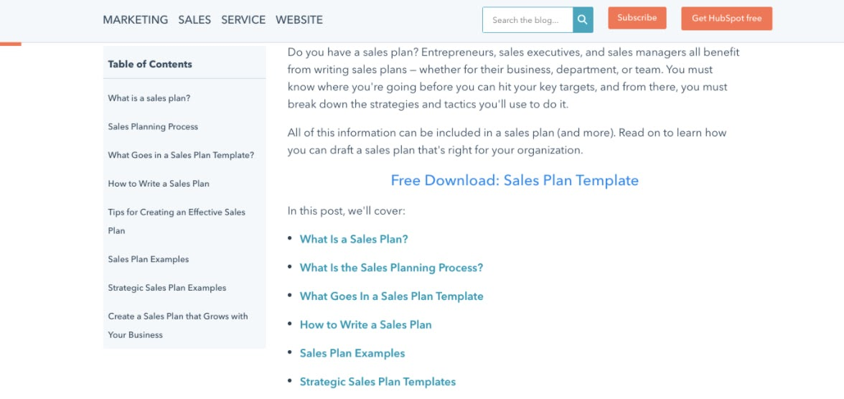

Both variants B and C did not increase the conversion rate on blog posts. The control condition outperformed variant B by 7% and performed equally with variant C. Also, few users interacted with the new TOC module or the CTA inside the module.

**5. Review Notifications**

To determine the best way of gathering customer reviews, we ran a split test of email notifications versus in-app notifications. Here, the independent variable was the type of notification and the dependent variable was the percentage of those who left a review out of all those who opened the notification.

In the control, HubSpot sent a plain text email notification asking users to leave a review. In variant B, HubSpot sent an email with a certificate image including the user’s name.



For variant C, HubSpot sent users an in app-notification.



Ultimately, both emails performed similarly and outperformed the in-app notifications. About 25% of users who opened an email left a review versus the 10.3% who opened in-app notifications. Emails were also more often opened by users.